`ME 780: Vehicle System Dynamics
Assignment #2
Due date: July 13, 2026
Description:
Consider the s SUV vehicle in CarSim:
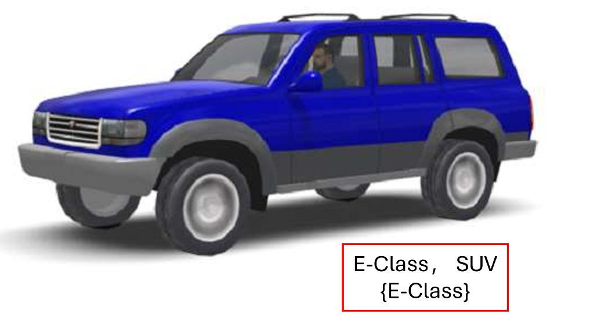
Part 1: Vehicle Specification
Extract the SUV car specifications from the CarSim and report the following parameters:
- Horsepower
- Maximum engine speed
- Gear ratios
- Tire dimensions
- Wheelbase
- Overall length\width\height
- Front\Rear track width
- Ground clearance
- Curb weight
- CG height
- Coefficient of drag at zero Aero slip angle
- Frontal area

Part 2: Performance metrics Prediction
- Find the approximated parabolic form of the engine torque characteristics curve. Consider the maximum throttle position, throttle position = 1.
Using the equations derived in the lectures and assuming 100% efficiency for the transmission and differential:
- Calculate the maximum speed of the car
- Calculate the accelerating time from 0 to 100 Km/h.
- Calculate the maximum Gradability of the car for dry road: coefficient of friction = 1, and wet asphalt: coefficient of friction = 0.5.
- Compare the calculated performance metrics with the CarSim results. Hint: use CarSim procedure: “Accel then Brake 0-100-0 km/h” and change the target velocity to the calculated value to be able to compare the results.
Part 3: Vehicle Dynamic
- Formulate the single-track handling model of the vehicle in the state space format (Bicycle model) using the equations derived in the lectures
- Simulate the response of the vehicle for a double lane change maneuver (steering input) with a constant longitudinal velocity of 35 km/h using Matlab/Simulink. Compare your results with the Matlab/Simulink Vehicle Dynamics Toolbox and CarSim simulation. Comment on the validity of the single-track handling model for a vehicle.
- Calculate the understeer coefficient for the vehicle. At what longitudinal speed does the vehicle become unstable? Show the instability condition with respect to the calculated velocity using CarSim simulations and discuss the results. Repeat the simulation at the same longitudinal speed for different road friction coefficients (icy road conditions) and discuss how tire-road friction influences the vehicle stability and handling response.

